HOWTO INSTALL THIS APP

1) Download the APK

2) Click on Settings

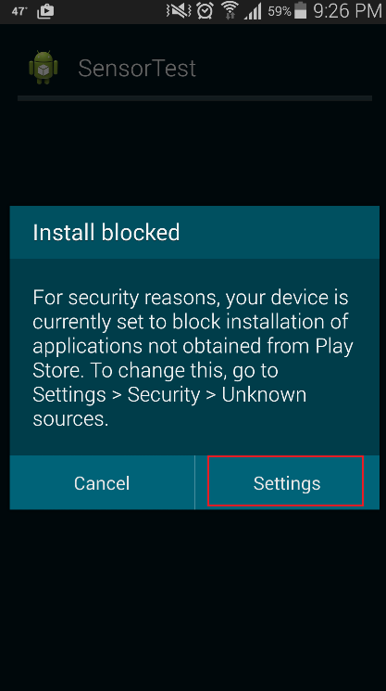

3) Go to Unknown Source and check he check box (This app is in a beta phase which means it is in testing phase so this needs to be done). No confidential data will be carried on using this device except your IMIE number or device id.

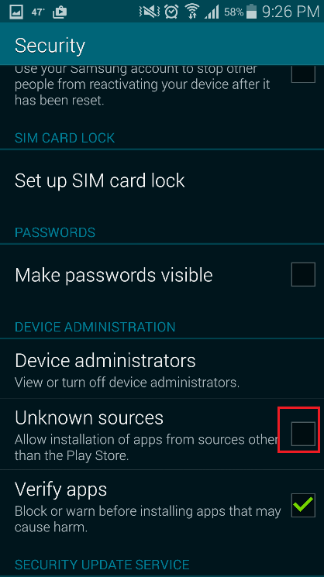

4) Click on Okay

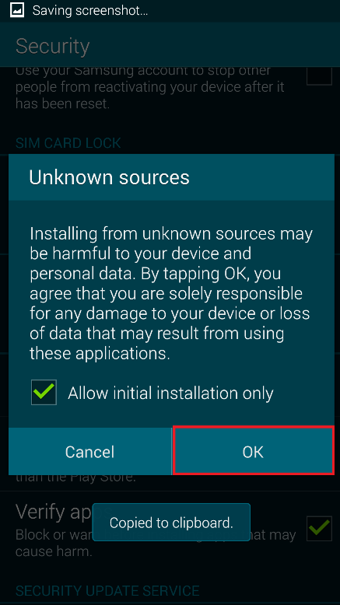

5) Click on Install

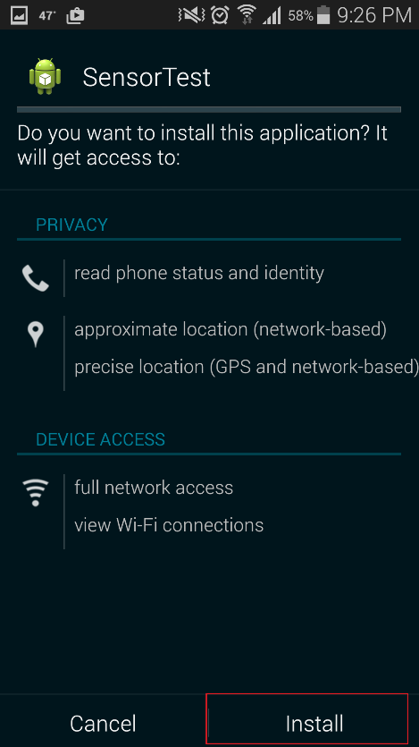

6) Click on open and this app is ready to be used